HARDWARE DESIGN

1. ARDUINO UNO

Basically it is an microcontroller based on architecture of ATmega328P that are being program with Processing language that has been modified that later being called Arduino IDE.

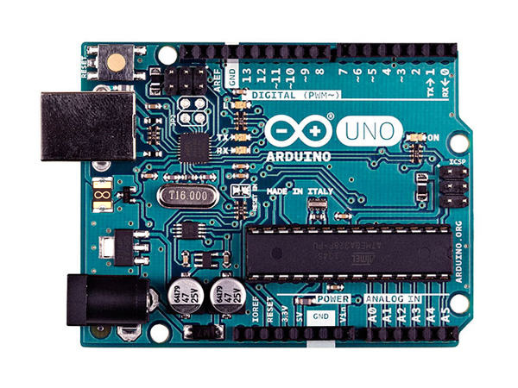

The Arduino UNO are remarkable for enthusiast in electronic as it is affordable to obtain while still providing the necessary features such as PWM, ADC, Digital I/O, I2C, SPI and Serial Connectivity.

The device are the key player in this project as it would work on the process required from the multiple input and output from sensors, LCD and Android phone.

1. LCD DISPLAY / I2C

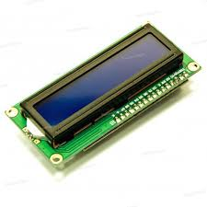LCD stand for Liquid Crystal Display, is a component with a flat panel, electronic visual display that uses light modulating properties of liquid crystal. LCDs are available to display arbitrary images as in a general-purpose computer display or fixed images with low information content, which can be displayed or hidden, such as pre-set words, characters, digits or 7 segment displays.

The function of using LCD in our designed Autonomous System is to show the current value of percentage that we tuned based on analogue value from potentiometer (act as controller/sensor).

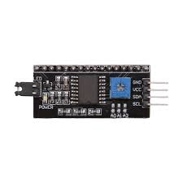

Inter-Intergrated Circuit (I2C) is typically used for attaching lower-speed peripheral ICs to processors and microcontroller in short distance, intra-board communication. I2C was connected to LCD to reduce the number of pins used before connected to Arduino. With this, only 4 pins connected to Arduino which are Vcc, Gnd, SDA and SCL.

To command or write the program code for LCD with I2C, it need a LiquidCrystal_I2C.h as it library header along with initializing the LCD with LiquidCrystal_I2C lcd(0x27, 16, 2); After that, just use the command for LCD as usual.

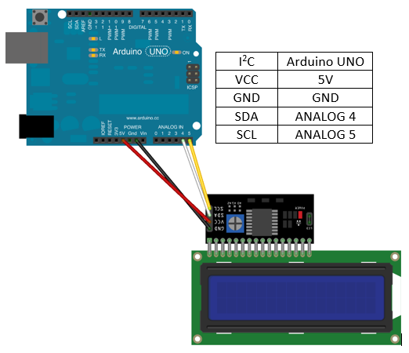

1. RFID MODULE

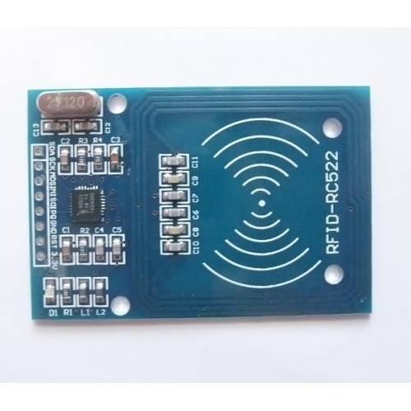

Radio frequency identification which known as RFID, is the use of radio waves to read and capture information stored on a tag that attached to an object. RFID modules use electromagnetic fields to transfer data between card and the reader.

Our project use read-write data RC522 model, based on NPX chip MFRC522. The specification tag is Mifare MF15503 with 1 kilobyte EEPROM. It works on Serial Peripheral Interface (ISP) protocol, when interfaced with Arduino board with operating frequency, 13.56 MHz.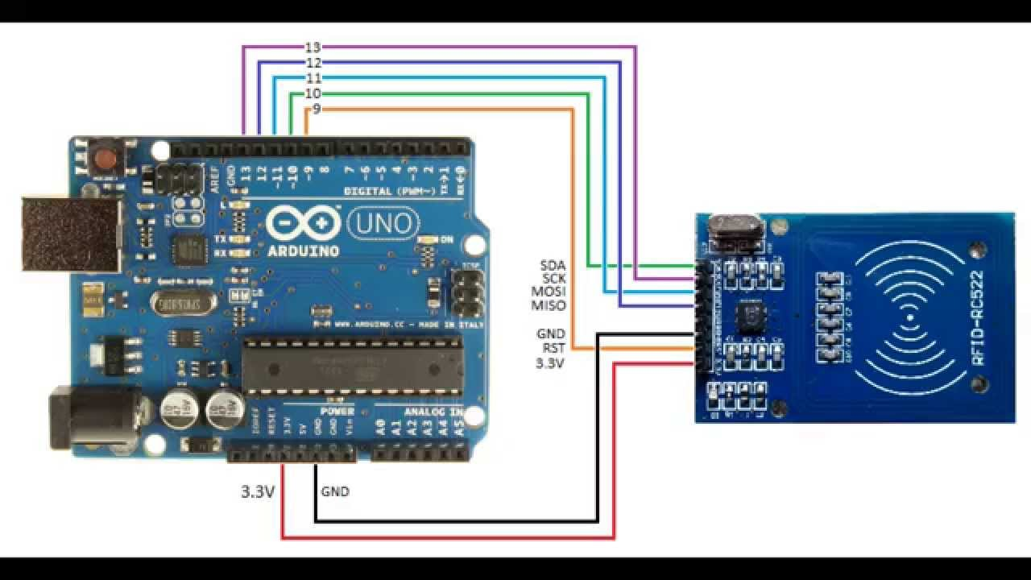

1. 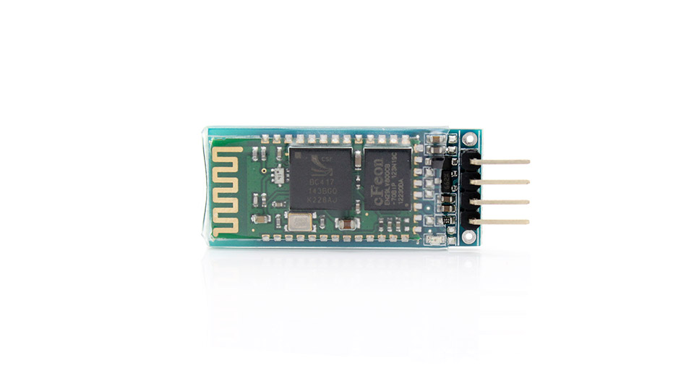HC06 BLUETOOTH MODULE

Bluetooth are vastly being known as a medium for communication from one end to another and its own credibility on transmitting the data on a low wattage.

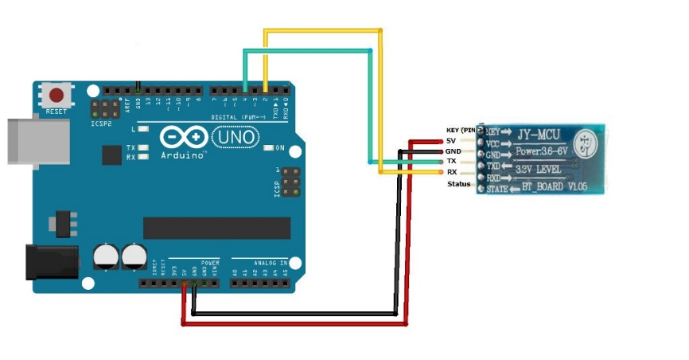It is a wireless technology that used UHF radio waves (2.4 GHz – 2.485 GHz) that would travel in a short distance. The range are usually around 5 m to 400 m depend on the configuration and architecture on board.

In this project, Bluetooth module are crucial element as it are needed to communicate between Arduino UNO and Android phone through an built application. The Bluetooth are connected serially to the Arduino using pin TX and RX.

SOFTWARE DESIGN

1. ANDROID STUDIO SOFTWARE

It is an official IDE for the android application development tool after Eclipse Android Development Tools (ADT) with tons of enhance features and improvement that benefit to developer itself and the end user. The software are based on IntelliJ IDEA with Java language as the core for the application processing. The layout or the interface of the user interface (UI) are being written in XML file while it is compatible to be combined with other UI written language such as HTML, CSS and etc.

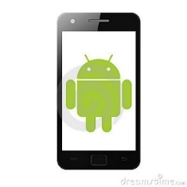As the rubric mentioned the extra marks on the software used/created, our team decided to develop an application that will enable the two way communication between Arduino and Android. Since the project are about automated agriculture, the application are named as AgriCU that stand for ‘Agriculture Control Unit’.

The develop application are expected to be able to give several specific command to Arduino through Bluetooth communication such as light intensity control, water dispenser control, enclosed temperature control and data display command while continuously receiving data on the Arduino sensor and display it on Android phone when called.

**Arduino UNO Code**

#include <Wire.h>   
#include <LiquidCrystal_I2C.h>  
#include "AddicoreRFID.h"  
#include <SPI.h>

#define uchar unsigned char  
#define uint unsigned int

uchar fifobytes;  
uchar fifoValue;

AddicoreRFID myRFID;

const int chipSelectPin = 10;  
const int NRSTPD = 5;

//Maximum length of the array  
#define MAX_LEN 16

LiquidCrystal_I2C lcd(0x27,16,2);

int led = 3;  
int tim = 10;  
int value_roof;  
int percent_roof;  
int value_water;  
int percent_water;  
int value_humidity;  
int percent_humidity;  
int a=0, b=0, receivedata=0;

const int analogInPin0 = A0;  
const int analogInPin1 = A1;  
const int analogInPin2 = A2;

float sensorValue[3] = {0,0,0};  
float voltageValue[3] = {0,0,0};

char inbyte = 0,btnbyte;

int roofSensor, waterSensor;

void setup(){  
 Serial.begin(9600);  
 initLCD();  
 initRFID();

pinMode(led, OUTPUT);  
 digitalWrite(led, LOW);

}

void loop() {  
 readSensors();

getVoltageValue();

sendAndroidValues();

workLCD();

workRFID();

btnbyte = Serial.read();

}

//::::::::::::::::::::::::::RFID-COMMAND::::::::::::::::::::::::::::::::::

void withSecurity(void){  
 if (btnbyte == '0'){

digitalWrite(led, LOW);

}

if (btnbyte == '1'){

digitalWrite(led, HIGH);

}

}

void withoutSecurity(void){

if (btnbyte == '0'){

digitalWrite(led, HIGH);

}

if (btnbyte == '1'){

digitalWrite(led, LOW);

}

}

//^^^^^^::::::::::RFID-COMMAND::::::::::::::^^^^^^

//::::::::::::::::::::::::::SENSOR::::::::::::::::::::::::::::::::::

void readSensors(){

// read the analog in value to the sensor array

sensorValue[0] = analogRead(analogInPin0);

sensorValue[1] = analogRead(analogInPin1);

sensorValue[2] = analogRead(analogInPin2);

}

void getVoltageValue(){

for (int x = 0; x < 3; x++){

voltageValue[x] = ((sensorValue[x]/1023)*100);

}

}

//sends the values from the sensor over serial to BT module  
void sendAndroidValues(){

//puts # before the values so our app knows what to do with the data

Serial.print('#');

//for loop cycles through 4 sensors and sends values via serial

for(int k=0; k<3; k++){

Serial.print(voltageValue[k]);

Serial.print('+');

//technically not needed but I prefer to break up data values

//so they are easier to see when debugging

}

Serial.print('~'); //used as an end of transmission character - used in app for string length

Serial.println();

delay(10); //added a delay to eliminate missed transmissions

}

//::::::::::^^^^^^::::::::::SENSOR::::::::::::::^^^^^^::::::::::::::

//::::::::::::::::::::::::::LCDD::::::::::::::::::::::::::::::::::

void initLCD(void) {

lcd.init(); //initialize the lcd

lcd.backlight(); //open the backlight

lcd.setCursor(0,0); // set the cursor to column 15, line 0

lcd.print("Roof : "); // Print a message to the LCD.

lcd.setCursor(0,1); // set the cursor to column 15, line 0

lcd.print("Water: "); // Print a message to the LCD.

}

void workLCD(void) {

value_roof=sensorValue[0];

percent_roof=((value_roof/1023.0)*100);

value_water=sensorValue[1];

percent_water=((value_water/1023.0)*100);

lcd.setCursor(7,0); // set the cursor to column 15, line 0

lcd.print(percent_roof);// Print value of percent_roof

lcd.print("%");

lcd.setCursor(7,1); // set the cursor to column 15, line 0

lcd.print(percent_water);// Print value of percent_water

lcd.print("%");

delay(tim); //wait for 250 microseconds

if(percent_roof==30)//data roof dari fon

{

if(a == 0){

lcd.setCursor(12,0);

lcd.print("Done");

a = 1;

}

}

if(percent_water==60)//data water dari fon

{

if(b == 0){

lcd.setCursor(12,1);

lcd.print("Done");

b = 1;

}

}

else{

lcd.setCursor(12,0);

lcd.print(" ");

lcd.setCursor(12,1);

lcd.print(" ");

a = 0;

b = 0;

}

}

//::::::::::^^^^^^::::::::::LCDD::::::::::::::^^^^^^::::::::::::::

//::::::::::::::::::::::::::RFID::::::::::::::::::::::::::::::::::

void initRFID(void){

// start the SPI library:

SPI.begin();

pinMode(chipSelectPin,OUTPUT); // Set digital pin 10 as OUTPUT to connect it to the RFID /ENABLE pin

digitalWrite(chipSelectPin, LOW); // Activate the RFID reader

pinMode(NRSTPD,OUTPUT); // Set digital pin 10 , Not Reset and Power-down

digitalWrite(NRSTPD, HIGH);

myRFID.AddicoreRFID_Init();

}

void workRFID(void){

uchar i, tmp, checksum1;

uchar status;

uchar str[MAX_LEN];

uchar RC_size;

uchar blockAddr; //Selection operation block address 0 to 63

String mynum = "";

str[1] = 0x4400;

//Find tags, return tag type

status = myRFID.AddicoreRFID_Request(PICC_REQIDL, str);

//Anti-collision, return tag serial number 4 bytes

status = myRFID.AddicoreRFID_Anticoll(str);

if (status == MI_OK)

{

if(str[0] == 64) //You can change this to the first byte of your tag by finding the card's ID through the Serial Monitor

{

withSecurity();

}

}

else if(status == MI_NO_TAG_ERR){

withoutSecurity();

}

myRFID.AddicoreRFID_Halt(); //Command tag into hibernation

}

//::::::::::^^^^^^::::::::::RFID::::::::::::::^^^^^^::::::::::::::

**Android Studio Code**

JAVA File:  
**Device List Activity**

package com.airul.agricu_v2;

import java.util.Set;

import android.app.Activity;

import android.bluetooth.BluetoothAdapter;

import android.bluetooth.BluetoothDevice;

import android.content.Intent;

import android.os.Bundle;

import android.util.Log;

import android.view.View;

import android.widget.AdapterView;

import android.widget.ArrayAdapter;

import android.widget.Button;

import android.widget.ListView;

import android.widget.TextView;

import android.widget.Toast;

import android.widget.AdapterView.OnItemClickListener;

public class DeviceListActivity extends Activity {

// Debugging for LOGCAT

private static final String TAG = "DeviceListActivity";

private static final boolean D = true;

// declare button for launching website and textview for connection status

Button tlbutton;

TextView textView1;

// EXTRA string to send on to mainactivity

public static String EXTRA_DEVICE_ADDRESS = "device_address";

// Member fields

private BluetoothAdapter mBtAdapter;

private ArrayAdapter<String> mPairedDevicesArrayAdapter;

@Override

protected void onCreate(Bundle savedInstanceState) {

super.onCreate(savedInstanceState);

setContentView(R.layout.device_list);

}

@Override

public void onResume()

{

super.onResume();

//***************

checkBTState();

textView1 = (TextView) findViewById(R.id.connecting);

textView1.setTextSize(40);

textView1.setText(" ");

// Initialize array adapter for paired devices

mPairedDevicesArrayAdapter = new ArrayAdapter<String>(this, R.layout.device_name);

// Find and set up the ListView for paired devices

ListView pairedListView = (ListView) findViewById(R.id.paired_devices);

pairedListView.setAdapter(mPairedDevicesArrayAdapter);

pairedListView.setOnItemClickListener(mDeviceClickListener);

// Get the local Bluetooth adapter

mBtAdapter = BluetoothAdapter.getDefaultAdapter();

// Get a set of currently paired devices and append to 'pairedDevices'

Set<BluetoothDevice> pairedDevices = mBtAdapter.getBondedDevices();

// Add previosuly paired devices to the array

if (pairedDevices.size() > 0) { findViewById(R.id.title_paired_devices).setVisibility(View.VISIBLE);//make title viewable

for (BluetoothDevice device : pairedDevices) {

mPairedDevicesArrayAdapter.add(device.getName() + "\n" + device.getAddress());

}

} else {

String noDevices = getResources().getText(R.string.none_paired).toString();

mPairedDevicesArrayAdapter.add(noDevices);

}

}

// Set up on-click listener for the list (nicked this - unsure)

private OnItemClickListener mDeviceClickListener = new OnItemClickListener() {

public void onItemClick(AdapterView<?> av, View v, int arg2, long arg3) {

textView1.setText("Connecting...");

// Get the device MAC address, which is the last 17 chars in the View

String info = ((TextView) v).getText().toString();

String address = info.substring(info.length() - 17);

// Make an intent to start next activity while taking an extra which is the MAC address.

Intent i = new Intent(DeviceListActivity.this, MainActivity.class);

i.putExtra(EXTRA_DEVICE_ADDRESS, address);

startActivity(i);

}

};

private void checkBTState() {

// Check device has Bluetooth and that it is turned on

mBtAdapter=BluetoothAdapter.getDefaultAdapter(); // CHECK THIS OUT THAT IT WORKS!!!

if(mBtAdapter==null) {

Toast.makeText(getBaseContext(), "Device does not support Bluetooth", Toast.LENGTH_SHORT).show();

} else {

if (mBtAdapter.isEnabled()) {

Log.d(TAG, "...Bluetooth ON...");

} else {

//Prompt user to turn on Bluetooth

Intent enableBtIntent = new Intent(BluetoothAdapter.ACTION_REQUEST_ENABLE);

startActivityForResult(enableBtIntent, 1);

}

}

}

}

**Android Studio Code**

JAVA File:  
**Main Activity**

package com.airul.agricu_v2;

import java.io.IOException;

import java.io.InputStream;

import java.io.OutputStream;

import java.util.Timer;

import java.util.TimerTask;

import java.util.UUID;

import android.app.Activity;

import android.bluetooth.BluetoothAdapter;

import android.bluetooth.BluetoothDevice;

import android.bluetooth.BluetoothSocket;

import android.content.Intent;

import android.os.Bundle;

import android.os.Handler;

import android.view.View;

import android.view.View.OnClickListener;

import android.widget.Button;

import android.widget.CompoundButton;

import android.widget.SeekBar;

import android.widget.TextView;

import android.widget.Toast;

import android.widget.ToggleButton;

public class MainActivity extends Activity {

Button btnOn, btnOff, btnData, btnRoof, btnWater, btnTemp;

TextView txtArduino, txtString, txtStringLength, textView;

Handler bluetoothIn;

final int handlerState = 0; //used to identify handler message

int point = 0, receivedata = 0;

private BluetoothAdapter btAdapter = null;

private BluetoothSocket btSocket = null;

private StringBuilder recDataString = new StringBuilder();

private ConnectedThread mConnectedThread;

private OutputStream outputStream;

// SPP UUID service - this should work for most devices

private static final UUID BTMODULEUUID = UUID.fromString("00001101-0000-1000-8000-00805F9B34FB");

// String for MAC address

private static String address;

private static SeekBar seek_bar;

private static TextView text_view;

private static ToggleButton toggle;

@Override

public void onCreate(Bundle savedInstanceState) {

super.onCreate(savedInstanceState);

setContentView(R.layout.activity_main);

//Link the buttons and textViews to respective views

btnOn = (Button) findViewById(R.id.buttonON);

btnOff = (Button) findViewById(R.id.buttonOff);

btnData = (Button) findViewById(R.id.buttonData);

btnRoof = (Button) findViewById(R.id.buttonRoof);

btnTemp = (Button) findViewById(R.id.buttonTemp);

btnWater = (Button) findViewById(R.id.buttonWater);

txtString = (TextView) findViewById(R.id.txtString);

txtStringLength = (TextView) findViewById(R.id.testView1);

seek_bar = (SeekBar)findViewById(R.id.seekBar);

text_view =(TextView)findViewById(R.id.textViewSlider);

ToggleButton toggle = (ToggleButton) findViewById(R.id.toggleButton);

seekBar();

textView = (TextView) findViewById(R.id.textView);

bluetoothIn = new Handler() {

public void handleMessage(android.os.Message msg) {

if (msg.what == handlerState) { //if message is what we want

String readMessage = (String) msg.obj; // msg.arg1 = bytes from connect thread

recDataString.append(readMessage); //keep appending to string until ~

//:::::::::::::::START::::::::::::::::

int endOfLineIndex = recDataString.indexOf("~"); // determine the end-of-line

if (endOfLineIndex > 0) { // make sure there data before ~

String dataInPrint = recDataString.substring(0, endOfLineIndex); // extract string

if (recDataString.charAt(0) == '#') //if it starts with # we know it is what we are looking for

{

String sensor0 = recDataString.substring(1, 6); //get sensor value from string between indices 1-5

String sensor1 = recDataString.substring(7, 12); //same again...

String sensor2 = recDataString.substring(13, 18);

textView.setTextSize(30);

textView.setText("Light Intensity\t\t= " + sensor0 + "%\n" +

"Temperature\t\t\t= " + sensor1 + "%\n" +

"Humidity\t\t\t\t\t\t\t\t= " + sensor2 + "%\n");

}

else if (recDataString.charAt(0) == '$') {

}recDataString.delete(0, recDataString.length());

}

}

}

};

btAdapter = BluetoothAdapter.getDefaultAdapter(); // get Bluetooth adapter

checkBTState();

toggle.setOnCheckedChangeListener(new CompoundButton.OnCheckedChangeListener() {

@Override

public void onCheckedChanged(CompoundButton buttonView, boolean isChecked) {

if (isChecked) {

// The toggle is enabled

mConnectedThread.write("1"); // Send "1" via Bluetooth

Toast.makeText(getBaseContext(), "Turn on LED", Toast.LENGTH_SHORT).show();

} else {

// The toggle is disabled

mConnectedThread.write("0"); // Send "0" via Bluetooth

Toast.makeText(getBaseContext(), "Turn off LED", Toast.LENGTH_SHORT).show();

}

}

});

// Set up onClick listeners for buttons to send 1 or 0 to turn on/off LED

btnOff.setOnClickListener(new OnClickListener() {

public void onClick(View v) {

mConnectedThread.write("0"); // Send "0" via Bluetooth

Toast.makeText(getBaseContext(), "Turn off LED", Toast.LENGTH_SHORT).show();

}

});

btnOn.setOnClickListener(new OnClickListener() {

public void onClick(View v) {

mConnectedThread.write("1"); // Send "1" via Bluetooth

Toast.makeText(getBaseContext(), "Turn on LED", Toast.LENGTH_SHORT).show();

}

});

}

private BluetoothSocket createBluetoothSocket(BluetoothDevice device) throws IOException {

return device.createRfcommSocketToServiceRecord(BTMODULEUUID);

//creates secure outgoing connecetion with BT device using UUID

}

@Override

public void onResume() {

super.onResume();

//Get MAC address from DeviceListActivity via intent

Intent intent = getIntent();

//Get the MAC address from the DeviceListActivty via EXTRA

address = intent.getStringExtra(DeviceListActivity.EXTRA_DEVICE_ADDRESS);

//create device and set the MAC address

BluetoothDevice device = btAdapter.getRemoteDevice(address);

try {

btSocket = createBluetoothSocket(device);

} catch (IOException e) {

Toast.makeText(getBaseContext(), "Socket creation failed", Toast.LENGTH_LONG).show();

}

// Establish the Bluetooth socket connection.

try

{

btSocket.connect();

} catch (IOException e) {

try

{

btSocket.close();

} catch (IOException e2)

{

//insert code to deal with this

}

}

mConnectedThread = new ConnectedThread(btSocket);

mConnectedThread.start();

//I send a character when resuming.beginning transmission to check device is connected

//If it is not an exception will be thrown in the write method and finish() will be called

mConnectedThread.write("x");

}

@Override

public void onPause() {

super.onPause();

try

{

//Don't leave Bluetooth sockets open when leaving activity

btSocket.close();

} catch (IOException e2) {

//insert code to deal with this

}

}

//Checks that the Android device Bluetooth is available and prompts to be turned on if off

private void checkBTState() {

if(btAdapter==null) {

Toast.makeText(getBaseContext(), "Device does not support bluetooth", Toast.LENGTH_LONG).show();

} else {

if (btAdapter.isEnabled()) {

} else {

Intent enableBtIntent = new Intent(BluetoothAdapter.ACTION_REQUEST_ENABLE);

startActivityForResult(enableBtIntent, 1);

}

}

}

//create new class for connect thread

private class ConnectedThread extends Thread {

private final BluetoothSocket mmSocket; //NEW

private final InputStream mmInStream;

private final OutputStream mmOutStream;

//creation of the connect thread

public ConnectedThread(BluetoothSocket socket) {

mmSocket = socket; //NEW

InputStream tmpIn = null;

OutputStream tmpOut = null;

try {

//Create I/O streams for connection

tmpIn = socket.getInputStream();

tmpOut = socket.getOutputStream();

} catch (IOException e) { }

mmInStream = tmpIn;

mmOutStream = tmpOut;

}

public void run() {

byte[] buffer = new byte[1024]; //NEW

int bytes;

// Keep looping to listen for received messages

while (true) {

try {

bytes = mmInStream.read(buffer); //read bytes from input buffer

String readMessage = new String(buffer, 0, bytes);

// Send the obtained bytes to the UI Activity via handler

bluetoothIn.obtainMessage(handlerState, bytes, -1, readMessage).sendToTarget();

} catch (IOException e) {

break;

}

}

}

//write method

public void write(String input) {

byte[] msgBuffer = input.getBytes(); //converts entered String into bytes

try {

mmOutStream.write(msgBuffer); //write bytes over BT connection via outstream

} catch (IOException e) {

//if you cannot write, close the application

Toast.makeText(getBaseContext(), "Connection Failure", Toast.LENGTH_LONG).show();

finish();

}

}

}

public void seekBar( ){

text_view.setText(seek_bar.getProgress() + " %");

seek_bar.setOnSeekBarChangeListener(

new SeekBar.OnSeekBarChangeListener() {

int progress_value;

@Override

public void onProgressChanged(SeekBar seekBar, int progress, boolean fromUser) {

progress_value = progress;

text_view.setText(seek_bar.getProgress() + " %");

// Toast.makeText(MainActivity.this,"SeekBar in progress",Toast.LENGTH_LONG).show();

}

@Override

public void onStartTrackingTouch(SeekBar seekBar) {

// Toast.makeText(MainActivity.this,"SeekBar in StartTracking",Toast.LENGTH_LONG).show();

}

@Override

public void onStopTrackingTouch(SeekBar seekBar) {

text_view.setText(seek_bar.getProgress() + " %");

// Toast.makeText(MainActivity.this,"SeekBar in StopTracking",Toast.LENGTH_LONG).show();

}

}

);

}

}